Referencing Images – simplified version

Contents
Should I use this guide? 1
Introduction 2
Presentation of figures and tables 2
Format of references 3
A note about copyright 3
Reference examples 4
A figure or table from a web page 4
A figure or table from a book 5
A figure or table from a journal article 6
Clip art and stock images 7
A figure or table you have adapted 8
Your own figures and tables 9
A table you have created from other sources 10
Creating a List of Figures or a List of Tables 11
Reference List Layout 12

Should I use this guide?

The APA 7th Style has complex instructions for the presentation and referencing of figures and tables. You can see details of these on pp. 27-33 of our Referencing Handbook: APA 7th Style
This guide presents a simplified style for referencing images. It should only be used for Salford student assessments. If you are writing for publication you should follow the full guidelines, as in our handbook above, or on the APA website.
You may need to ask your tutor whether they want you use the style outlined in this guide, or the full APA 7th style for figures and tables.

Introduction

When you are writing an assignment or dissertation you may wish to use images, such as tables, photographs, diagrams, maps and charts, to illustrate a point or describe what you are writing about. If you did not create the images yourself, you must acknowledge them as you would in written work.
Images fall into two categories:
Figures Photographs, drawings, diagrams, graphs, flowcharts, maps, etc.
Tables Text and / or numbers arranged in orderly columns and rows.

Presentation of figures and tables

Every time you use a figure or a table in your writing, it should be referred to three times:
1. In a heading and caption: These are place immediately above and below the image and need
to include the following information:
Number Above the image, in italics. Use the word “Figure” or “Table” followed by a sequential number. Number your figures either consecutively (1, 2, 3), or number them in a multilevel sequence for each chapter, e.g. Figure 1.1, Figure 1.2, Figure 2.1.
Follow the number with a colon, e.g. Figure 2.1:
Title The title of the image should be in italics and Title Case, on the same line as the Number, e.g. Figure 1.2: The Interdisciplinary Field of Canine Science
Note Place below the image, and precede with the word ‘Note’. in italics. Follow this with the words ‘From’ or ‘Adapted from’ and an in-text citation for the source of the image, e.g.
Note. From Maclean et al., 2021, p. 2.

2. In your writing: Refer to every image by its number, and include a sentence or two
explaining why it’s there, for example:
As shown in Figure 3, … Table 2 shows …

3. As a reference in your Reference List:
- The references for figures and tables are included in the same reference list as your books, journal articles, etc.
- If you are writing a large piece of work, such as your dissertation or thesis, and have used a lot of illustrative material, you should also create a List of Figures and/or List of Tables (see p. 11).
If you are unsure what to do, please speak to your tutor or supervisor.

Format of references
Creator – The creator of the work. Surname, followed by a comma, followed by initial(s). Include full stops and spaces between initials.
- If there is more than one creator put a comma between each name and an ampersand before the last name.
- If the work has been created by an association or institution, etc., use the organisation’s name as the author.
- If there is no creator, start the reference with the title of the work.

Year – the year the work was created (if known) enclosed in parentheses and followed by a full stop. If you don’t know the year, use (n.d.) – no date.
Title – The title of the figure or table, in plain font.
There are times when the image will not have a title – for example, you may have used a tool such as Digimap to create a map. If this is the case, give the image a description, enclosed in square brackets.
Format – the format or medium of the work, enclosed in square brackets. Follow a full stop, then the word In.
Source – The title of the source of the figure or table, (e.g. book, journal, webpage) in italics. If the image was taken from a journal include the volume, issue or article numbers. Follow by a full stop.
Page number – If the figure or table was taken from a print source (e.g. book, journal, report) include the number of the page it came from, preceded by p.
Publisher – If the figure or table was taken from a book or report, include the publisher’s name, followed by a full stop.
DOI or URL – If available.

A note about copyright

If you are writing a PhD thesis, which will be made available electronically on the University of Salford Institutional Repository, USIR, or are writing anything for publication (e.g. a book or journal article) you should seek copyright permission from the creators of any illustrative material that you use. Include a note at the end of your caption (see next page) stating that copyright permission has been granted, and reference the material fully according to the style appropriate for your discipline.

As student assignments and taught-course dissertations are not published (or publicly available like a PhD thesis) it is not necessary to obtain copyright permission, but you still must cite any illustrative material as a direct quotation and provide full reference details in your Reference List.

Reference examples

A figure or table from a web page

The following instructions are for images that you have found in various webs sources, such as webpages, blogs or wikis.
If the figure or table you are using came from a book or journal article, please follow the examples on pp. 5-6.

How to display it in your work
Figure 1: Nikola Tesla, With His Equipment
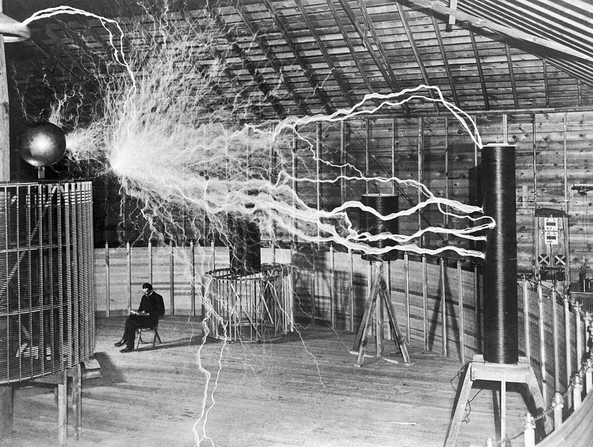
Note. From Alley, 1901.

Reference
Use this format to reference figures and tables you have found on the web.
Creator, A.B. (Year). Title of Figure or Table [Format]. In Title of webpage. https://.....

Example:
Alley, D. V. (1901). Nikola Tesla, with his equipment [Photograph]. In Wellcome Collection. https://wellcomecollection.org/works/sq2828s9

A figure or table from a book

How to display it in your work
Table 1: Sources of training for traders and artisans interviewed in Nairobi, 2015
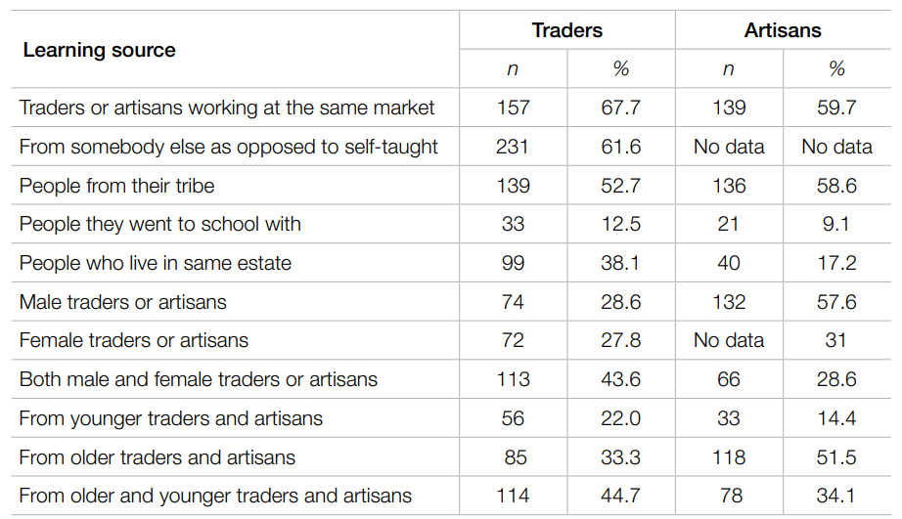
Note. From Njeri Kinyanjui, 2019, p. 147.

Reference
Use this format when the creator of the figure or table is the same person (or people) as the author of the book.
Creator, A.B. (Year). Title of Figure or Table [Format]. In Title of book (p. number). Publisher. https://.....
Reference List Example:
Njeri Kinyanjui, M. (2019). Sources of training for traders and artisans interviewed in Nairobi, 2015 [Table]. In African Markets and the Utu-buntu Business Model: A Perspective on Economic Informality in Nairobi (p. 147). African Minds. https://doi.org/10.5281/zenodo.2628333

If the creator of the figure or table is a different person to the author(s) or editor(s) of the book, use the following format:
Creator, A. B. (Year). Title of Figure or Table [Format]. In A. B. Author. (Year of publication, if different to the image) Title of book (p. number). Publisher. https://.....
Reference List Example:
Van Gogh, V. (1888). Memory of the Garden at Etten [Oil painting]. In D. Gamboni & C. Miller. (2014). Paul Gauguin : the mysterious centre of thought (p. 171). Reaktion Books.
The creator and date cited in the Note will be those of the original work, e.g. Van Gogh, 1888.

A figure or table from a journal article

How to display it in your work
Figure 2: The Interdisciplinary Field of Canine Science
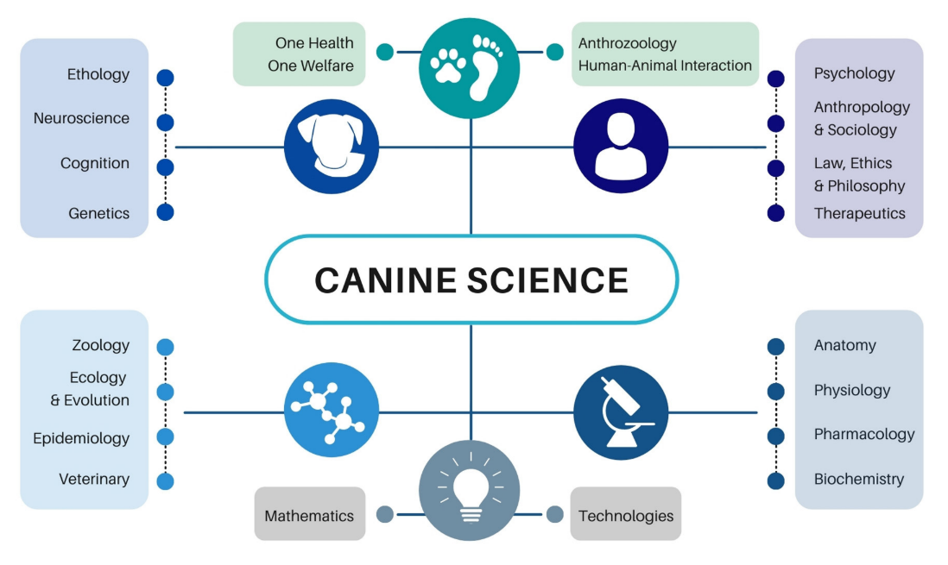
Note. From Maclean et al., 2021, p. 2.

Reference
Use this format to reference a figure or table you have found in a journal article.
Creator, A. B. (Year). Title of Figure or Table [Format]. In Journal Title, volume number(issue number) or Article number, p. number. https://...
Reference List Example:
MacLean, E. L., Fine, A., Herzog, H., Strauss, E., & Cobb, M. L. (2021). The Interdisciplinary Field of Canine Science [Diagram]. In Frontiers in Veterinary Science, 8, Article 675782, p. 2 https://doi.org/10.3389/fvets.2021.675782

If the creator of the figure or table is a different person to the author(s) or editor(s) of the book, use the following format:
Creator, A. B. (Year). Title of Figure or Table [Format]. In In Journal Title, volume number(issue number) or Article number, p. number. https://...
Reference List Example:
Gauguin, P. (1894). Self-Portrait with a Hat [Oil painting]. In Transatlantica, 2(2), p. 2 https://doi.org/10.4000/transatlantica.10968
The creator and date cited in the Note will be those of the original work, e.g. Gauguin, 1894.

Clip art and stock images

The clip art and stock images that are found in MS Word and PowerPoint are free to use and do not need a citation or reference.
Other sources of free images, such as Unsplash, Flickr and Pixabay may have licences which require referencing. In these cases, follow the guidance below.

How to display it in your work
Figure 3: Cat in a Backpack
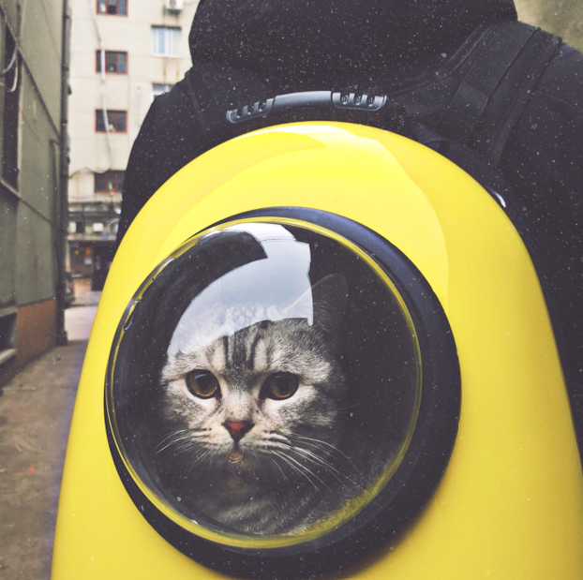
Note. From Zhao, 2018.

Reference
Use this format to reference a figure or table you have found on a free image-sharing site.
Creator, A. B. (Year). Title of Figure or Table [Format]. In Website. https://...

Reference List Example:
Zhao, K. (2018). Gray Tabby Cat in Yellow and Black Hand Case Backpack [Photograph]. In Unsplash. https://unsplash.com/photos/CVS4kWJaYLs

A figure or table you have adapted

There are times when you may wish to adapt someone else’s figure or table, for example, you may want to plot your own research results against an existing graph or add them to a table.
When you do this, follow the examples on pp. 4-7 for the source you have got the figure or table from, and in your caption use the words “Adapted from”.

How to display it in your work
Figure 4: Hull Pot Study Area
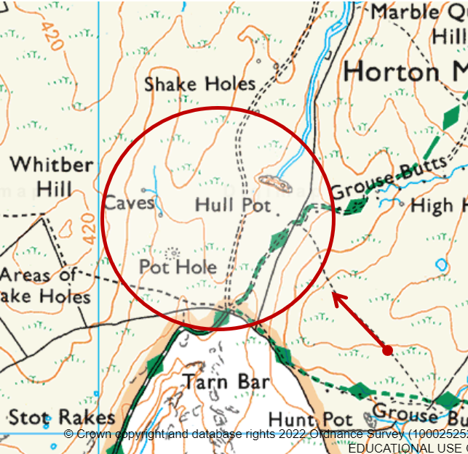
Note. Adapted from Ordnance Survey, 2022.

Reference
Follow the examples on pp. 4-7 for the type of information source of the figure or table.
Reference List Example:
Ordnance Survey. (2022). [Hull Pot, Pen-y-Ghent. Map]. In Digimap. https://digimap.edina.ac.uk/

In this example, Digimap has been used to create a map, so you need give it a title or description, enclosed in square brackets. The format “Map” should be within the same set of square brackets.

Your own figures and tables

If you use graphs, diagrams, photographs or other images in your work that you have created yourself, you do not need to reference them, but you do still need to give them a Figure or Table number and a title.

How to display it in your work
Figure 5: Motivation of Volunteers by Age Group
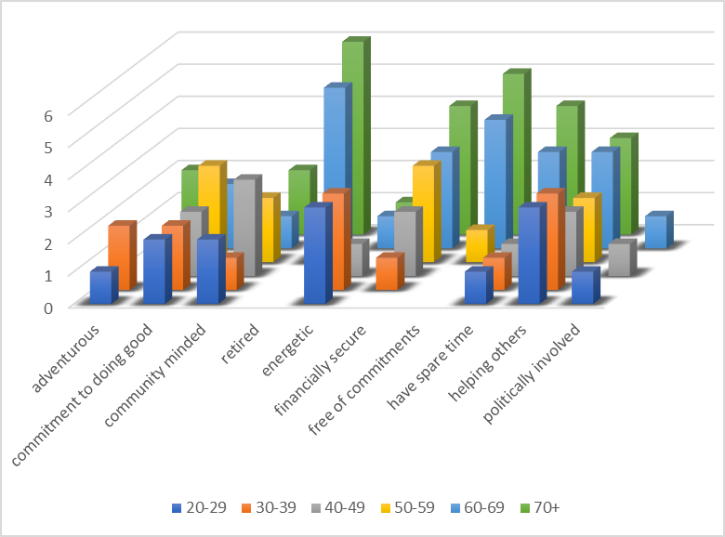

Reference
Because this is your own illustration, and not one you have found in a published work, do not give it a reference. However, if you are writing a large assessment such as a dissertation or thesis and are using a List of Figures or List of Tables (see p. 11) you should include the image in the list.

List of Figures Example:
Figure 5. Motivation of Volunteers by Age Group [Graph].

A table you have created from other sources

If you have used a table which you have created yourself by collating information you have found in another source or sources, you need to acknowledge the sources you have used. This should be in the form of a citation within your Note, including the words “Data from” and the source(s) of the data you have used.
You also need to provide an entry for the source or sources in your Reference List.

How to display it in your work
Table 2: Country Comparison of Population and Urbanisation, 2022
 | population | land area:  sq. km. | population per sq. km | urbanisation:  % of population
Cook Islands | 8,128 | 236 | 34.44 | 75.90%
Fiji | 943,737 | 18,274 | 51.64 | 58.20%
Kiribati | 114,189 | 811 | 140.80 | 57.10%
Marshall Islands | 79,906 | 181 | 441.47 | 78.50%
Nauru | 9,811 | 21 | 467.19 | 100%
New Zealand | 5,053,004 | 264,537 | 19.10 | 87%
Niue | 2,000 | 260 | 7.69 | 47.60%
Samoa | 206,179 | 2,831 | 72.83 | 17.60%
Tuvalu | 11,544 | 26 | 444.00 | 65.50%
Wallis and Futuna | 15,891 | 142 | 111.91 | 0.00%

Note. Data from Central Intelligence Agency, 2022

Reference
Do not provide a reference for your table – you have created it yourself and therefore it is not retrievable.
Instead, you must reference the source of your data or information.
Follow the Reference Examples for APA 7th, available at https://www.salford.ac.uk/skills/referencing/apa-7th-edition for the information source you have use, e.g. book, journal, website, etc.

Reference List Example:
Central Intelligence Agency. (2022). The World Factbook. https://www.cia.gov/the-world-factbook/countries/

Creating a List of Figures or a List of Tables
If you are writing a long assignment, such as your dissertation or thesis, and have used a number of figures and/or tables you should include in a List of Figures and a List of Tables.
A List of Figures and a List of Tables come at the start of your work, after your Table of Contents.
- List your figures in consecutive order, i.e. in the order they appear in your writing (not alphabetically as you would in a Reference List).
- Start each item with its number, e.g. Figure 1.
In the examples below these are multi-level numbers, by chapter.
- Follow the Figure Number with its Title.
- Add the page number for where you have used each image.
- Remember that any images you have created yourself should also be included in the list.
You can use the References – Caption and Table of Figures tools to create these lists for you automatically. You can find instructions for this in our Formatting your Dissertation guide at https://www.salford.ac.uk/sites/default/files/2020-06/Formatting-your-dissertation-or-thesis.pdf

List of Figures example
Figure 1.1. Memory of the Garden at Etten ……………………………….…………………………………………. p. 4
Figure 1.2 The Interdisciplinary Field of Canine Science ………………………………….…………………… p. 6
Figure 2.1 Self-Portrait with a Hat …………………….………………………………………………………………….. p. 6
Figure 2.2 Cat in a Backpack ……………………………………………..…………………………………….……………. p. 7
Figure 2.3 Hull Pot Study Area ……………………………………………..………………………………………………. p. 8
Figure 3.1 Motivation of Volunteers by Age Group …………………………………………………………….. p. 9

Follow the advice above to create a List of Tables, giving each one a Table Number.
List of Tables example
Table 1.1. Sources of training for traders and artisans interviewed in Nairobi, 2015 …………. p. 5
Table 2.1 The Interdisciplinary Field of Canine Science ………………………………….….……………… p. 10

More help with referencing can be found on our Skills pages at: https://www.salford.ac.uk/skills/referencing/apa-7th-edition

Reference List Layout

Your Reference List is a list of all the works cited in your paper, listed in one single alphabetical sequence at the end of your work. This means that the references for figures and tables will be listed alphabetically amongst the references you have for other information sources, such as books, journal articles and webpages.
If you have used a figure or table as well as text from a book, article, etc. you should reference both separately (for example, the Gauguin and Mathews references below).
Works with the same author(s) are then sorted chronologically by year, and if works have the same author(s) and year they are then sorted alphabetically by title.
You should use hanging indentation (as in the example below). You can do this by going to the Paragraph tools in the Home tab in Word and select Hanging from the Special menu.

Reference List example

Alley, D. V. (1901). Nikola Tesla, with his equipment [Photograph]. In Wellcome Collection. https://wellcomecollection.org/works/sq2828s9
Central Intelligence Agency. (2022). The World Factbook. https://www.cia.gov/the-world-factbook/countries/
Gamboni, D. (2014). Paul Gauguin: The Mysterious Centre of Thought. Reaktion Books.
Gauguin, P. (1894). Self-Portrait with a Hat [Oil painting]. In Transatlantica, 2(2), p. 2 https://doi.org/10.4000/transatlantica.10968
MacLean, E. L., Fine, A., Herzog, H., Strauss, E., & Cobb, M. L. (2021). The Interdisciplinary Field of Canine Science [Diagram]. In Frontiers in Veterinary Science, 8, Article 675782, p. 2 https://doi.org/10.3389/fvets.2021.675782
MacLean, E. L., Fine, A., Herzog, H., Strauss, E., & Cobb, M. L. (2021). The New Era of Canine Science: Reshaping Our Relationships With Dogs. Frontiers in Veterinary Science, 8, Article 675782. https://doi.org/10.3389/fvets.2021.675782
Mathews, N. M. (2019). Gauguin, Buffalo Bill, and the Cowboy Hat. Transatlantica, 2(2). https://doi.org/10.4000/transatlantica.10968
Njeri Kinyanjui, M. (2019). Sources of training for traders and artisans interviewed in Nairobi, 2015 [Table]. In African Markets and the Utu-buntu Business Model: A Perspective on Economic Informality in Nairobi (p. 147). African Minds. https://doi.org/10.5281/zenodo.2628333
Ordnance Survey. (2022). [Hull Pot, Pen-y-Ghent. Map]. In Digimap. https://digimap.edina.ac.uk/
Van Gogh, V. (1888). Memory of the Garden at Etten [Oil painting]. In D. Gamboni & C. Miller. (2014). Paul Gauguin : the mysterious centre of thought (p. 171). Reaktion Books.
Zhao, K. (2018). Gray Tabby Cat in Yellow and Black Hand Case Backpack [Photograph]. In Unsplash. https://unsplash.com/photos/CVS4kWJaYLs

