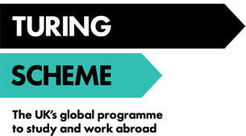

University of Salford International Opportunities Widening Participation Policy: Increasing access to Turing Scheme placements

To encourage University of Salford students to access international opportunities, including overseas study, trainee and volunteering placements, we actively encourage all students to participate in both funded and non-funded opportunities as part of our Turing Scheme project 2021-22.
It is widely understood that there are defined groups that are considered to Widening Participation students in terms of accessing higher education.
To further encourage students from backgrounds who would not traditionally take up international opportunities through higher education, whether this is due to cost, duration, location or confidence, we actively encourage to widen participation in mobility, and therefore have an extended definition of Widening Participation.
We define a student as being a Widening Participation (WP) student in terms of international opportunities as a student who meets one or more of the following attributes:
- A student who is considered to be from/reside in an area where there is a low participation in higher education
- A student who progressed to the University from a state school or college only and not from a selective state or independent school of college.
- A student who progressed to the University by achieving alternative qualifications to A/AS levels (for example, BTEC, access to HE or other qualifications)
- A student who is BAME status
- A student who has a declared disability
- A student who continues to live at home or is considered to be a commuter student during their university studies
- A student whose is first-generation to attend university
- A student who is studying a degree that leads to a public sector or public service profession (for example, Nursing)
- A student from a household with a low household income (for example, £25,000 or less)
- A student from a household considered as low SEC (for example, group 3 to 9)
- A student receiving Universal Credit or income-related benefits because they are financially supporting themselves or financially supporting themselves and someone who is dependent on them and living with them, such as a child or partner
- A student who is care-experienced
- A student who has caring responsibilities
- A student who is estranged (for example, where neither of the students’ parents can be found or it is not reasonably practicable to get in touch with either of them)
- A student is a refugee or asylum seeker

