Group working: Sharing a File or Folder using Office 365
As a University of Salford student, you have your own Microsoft Office 365 account. It gives you access to MS Office software, such as Word, PowerPoint and Excel. You also have the option to install these and other Office applications onto five personal devices. Office 365 is a business standard set of tools and using it will help you develop valuable digital skills for your studies and for the workplace.
This guide explains how you can share a file or folder for group work, using OneDrive – your personal cloud file storage area.

To access your Office 365 account
Go to the Student Hub and sign in with your University email and password. All students in the group will need to do this when accessing the shared folder/file.

To create a shared folder or file
One person in the group must sign into their OneDrive account to create a file/folder and share it with the group. The folder/files will technically sit in their account, but it can be viewed (and edited, if permitted) when shared with the group.
- One group member signs into their OneDrive account by clicking on the App Launcher icon in the left corner of the screen (it looks like a waffle!)
- Choose OneDrive.
- Click on New and choose Folder or a File type, such as Word.
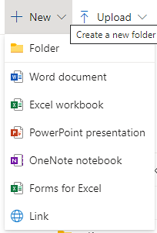
- Name the file/folder and click Create. The file/folder is private by default.
- Select the button to the left of the file/folder name and the Share button will appear at the top of the screen.
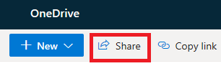
This opens the sharing options. These sharing options are consistent throughout Office 365.
- Take a look at the options and select the ones that suit your needs:
  - Click on People you specify can view to see more options.
  - Choose Specific people to restrict access of the file/folder to just the people whose names you enter.
  - For group work you should tick the box to Allow Editing, so that all group members can make any necessary changes.
  - Click Apply.
- Now enter the names of people you want to share the file/folder with, enter a short message and click Send. An email with a link to the file/folder will be sent to the people you added.
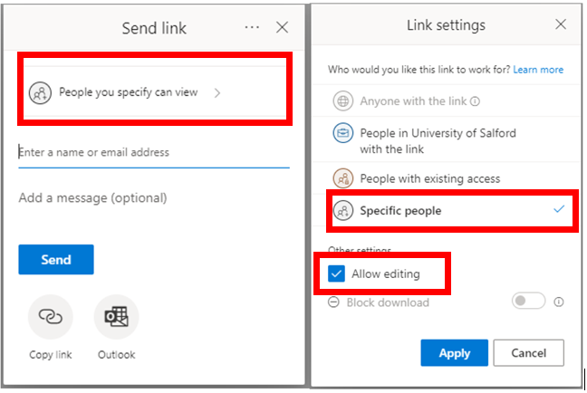

To access the shared file/folder
Everyone that you shared the file/folder with is now able to access it. If you have shared a folder then group members can also add their files to the shared folder.
- To see the shared file/folder the other group members should sign into their OneDrive and click on Shared to see the shared file or folder listed.
The owner of the OneDrive account can click on the three dots next to the file/folder and change the access permissions at any time. For example, you may be asked to share the files/folder with a lecturer.

