MS Teams – Online meetings
Got invited to a Teams meeting?
There is more than one way to join an online meeting. This guide explains how to go directly to Teams, but you could also join the online meeting via your O365 email meeting invite.

Logging into Office 365
- Log into Office 365, via the Salford Student Hub or via office.com, and log in with your University email address and password.

Joining your online meeting
- Click on the Teams icon or access it via the App launcher, or ‘waffle’ icon .
- Click on the Teams Calendar icon and navigate to the date/time of the online meeting.
- Click on the Join icon for the meeting.
- Click on the link Join Microsoft Teams Meeting.
Figure 1: the 'Join Microsoft Teams Meeting' link.
- There are audio and video settings to select. Switch on the audio/mic and switch on the camera in the first instance. (You switch these off/on again during the meeting…)
- Click Join now, and the online meeting is ready to begin.

If prompted to choose between Download the Windows app and Join on the web instead, choose the first option. It ensures a full functionality for online meetings.
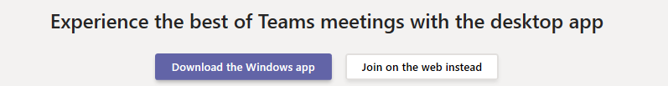
Figure 2: Choose ' Download the Windows app', if prompted

Features within your online meeting
Figure 3: Manage the meeting
- Length of meeting
- Camera – switch on or off. Inbuilt camera in your device, or plug in a webcam.
- Microphone – switch on or off. Inbuilt in your device, or plug in a microphone.
- Share – see below.
- More actions (Ellipses) – includes Start recording, Show device settings.
- Show Conversation – use the Chat panel to ask questions, make comments, etc.
- Show Participants – a list of who has joined the meeting.
- Hang up – use this to end the meeting.

Sharing your screen
Teams lets you share your screen and files with people in the meeting - you can also enable others to make changes to the screen/file in real time.
- Select Share.
- Select what you want to share:
  - Desktop lets you show everything on your screen.
  - Window lets you show a specific app.
  - PowerPoint lets you show a presentation.
  - Browse lets you find the file you want to show.
- After you select what you want to show, a red border surrounds what you're sharing.
- Select Stop sharing to stop showing your screen.

Other ways of starting an online meeting
Start a meeting right now? From Posts select the video icon > Click Meet now > Enter names into the Invite someone box.
Schedule a meeting in the future? Do it via Teams > Calendar > Schedule a meeting button.
Watch this video link…

Using a phone or table? Download the ‘Microsoft Teams’ app
The Teams app has great functionality. For an online meeting, tap the Calendar icon and tap the Join button for the meeting. You can still access that great sharing files feature.
Available on android and IOs, just download it via your device’s app store.

Further support
Videos via Microsoft: https://bit.ly/2Rj480j
Find lots of training videos on the features of MS Teams via LinkedIn Learning

