InTroduction
Potential arsenic contamination in drinking water sources of Tanzania and its link with local geology
J. Ijumulana^{1,2}, F. Mtalo¹ & P. Bhattacharya²
¹DAFWAT Research Group, Department of Water Resources Engineering, College of Engineering and Technology, University of Dar es Salaam, Dar es Salaam, Tanzania
²KTH-International Groundwater Arsenic Research Group, Department of Sustainable Development, Environmental Science and Engineering, KTH Royal Institute of Technology, Stockholm, Sweden

ABSTRACT: Recent studies on arsenic (As) occurrence particularly in African waters show that several sources of drinking water have elevated concentrations above national and international guidelines. In Tanzania, elevated concentrations of As above WHO guideline (10 µg/L) in Lake Victoria Gold fields is emerging as a threat to public health depending on groundwater and surface water as drinking water sources. In this study, spatial statistics and GIS tools have been used to delineate the relationship between As occurrence and local geological settings. Among the 12 mapped local geological units, the most targeted aquifers for potable water are characterized by granitoids, migmatite, mafic and ultramafic meta-sediments (~50% of water points). The probability of having As levels above WHO guideline was 0.71 and 0.33 for surface water and groundwater systems respectively.
High levels of arsenic (As) have been reported both in surface water and groundwater in several African countries (Ahoulé et al., 2015).The source, distribution and mobilization of As in aqueous environment differs by country and within same country differs by location and are associated with either geogenic or anthropogenic processes. Elevated concentrations of As has been reported in the northern part of Tanzania, particularly around the Lake Victoria Goldfields (LVGF) (Mnali, 2001; Lucca et al., 2017) within Lake Victoria Basin (LVB). In the LVGF, large spatial variability of As occurrence has been identified in terms of concentration as well as speciation which hinders meaningful conclusion on its fate based on the available database (Kassenga & Mato, 2008). The present study aims to investigate: i) the effects of local geological settings on the distribution of As and its concentrations in the drinking water sources; ii) the effects of climate on the variability of As in water sources; and iii) understand the probable links of the adverse health outcomes (viz. cancer cases) due to long term ingestion of inorganic As in drinking water sources in the region. In this abstracts results on spatial variability of arsenic occurrence with respect to local geological setting are presented.

MATERIALS AND METHODS

Study area
Lake Victoria Basin, Tanzanian part, is one of the 9 river basins in Tanzania mainland covering area of 119,442 sq.km. The region has little seasonal variation but the eastern sections where Mara region, the study area lies, average only 750 – 1000 mm of rain. Favourable climatic conditions for agriculture and livestock and the abundance of natural resources have supported the livlihood of the rural population of over 35 million people (Lucca et al., 2017). The geology of the Tanzanian LBV consists of Archean granitoids-greenstone belts hosted in the Tanzanian Craton. More than 80% of rural population depends on groundwater resources for various use.

Assessment of drinking water supply points in Lake Victoria Basin with respect to local geology
More than 80% of rural population in LVB depend on groundwater resources abstracted through boreholes, springs, shallow wells and deep wells. Approximately 50% of abstraction points target aquifers composed of migmatite-granitoid- metasediment complex, metasediments (~22%), sandy, gravelly, silty sediments (~10%), mafic volcanics, meta-basalts, phyllite-greenstone belt with BIF (~9%). The remaining 10% of groundwater abstraction points target aquifers characterized by the 8 remaining local geological units.

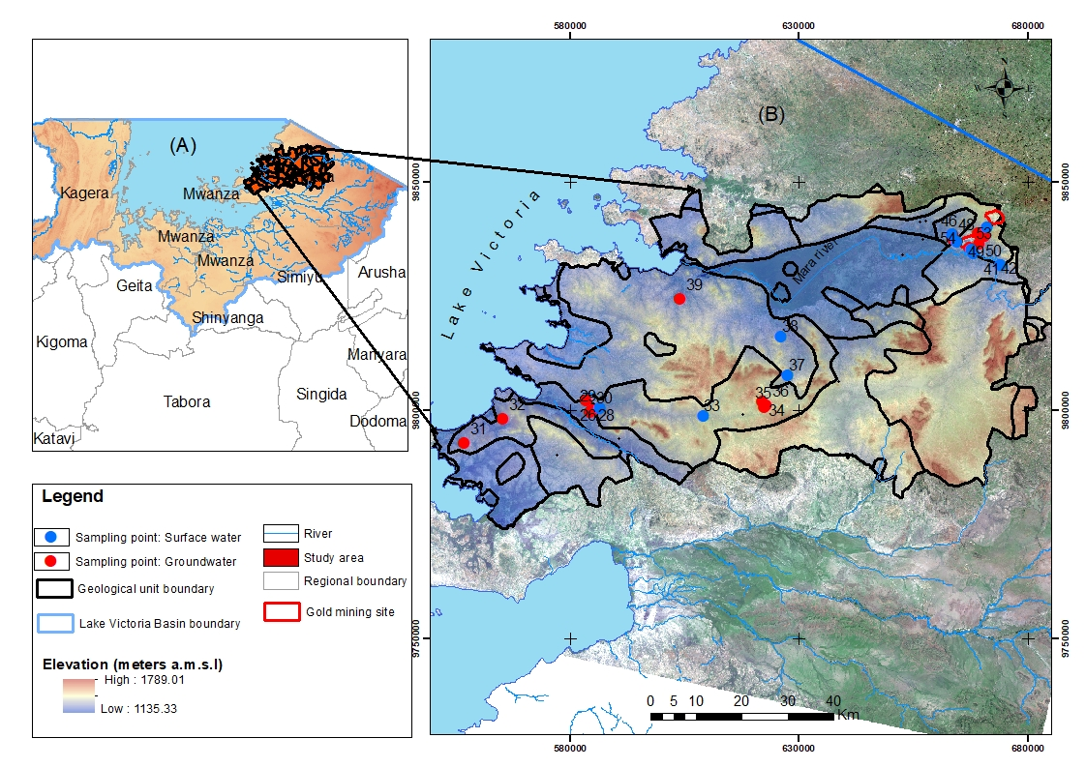
Figure 1. Study area (A) and water sampling locations (B).

Water sampling and laboratory analysis
Water sampling was carried out at the end of dry season during October 2016. A total of 29 water samples were collected, of which 18 samples were taken from groundwater sources and 11 samples from surface water sources were collected (Fig. 1). The physio-chemical parameters such as, pH, temperature (T), electrical conductivity (EC), redox potential (Eh) and elevation (H) were measured in the field. Major anions were analyzed by ion chromatography (IC Dionex DX-120) in the Land and Water Resources Engineering laboratory at KTH Royal Institute of Technology. Major cations were determined by inductively coupled plasma-optical emission spectrometry (ICP-OES) at Linköping University in the Department of Thematic Studies.

Creation of spatial database and data analysis
ArcGIS software was used to create spatial database comprising the location and description of each water sample, physio-chemical parameters and major ions and As. The data analysis part involved calculating and mapping of summary statistics, i.e. minimum, maximum, average and standard deviation.

results and discussion

Spatial exploration of water quality parameters with local geological settings
The collected water samples were from abstraction points targeting aquifers with following sediment types: i) predominantly alluvial and eluvial sediments (aQ) with slightly alkaline pH (7.4) and high Eh (mean +416 mV); ii) migmatite-granitoid-meta-sediment complex (miNA) with neutral pH (7.0) and higher Eh (356.4 mV mean); and iii) volcano-sedimentary complex-Greenstone Belt with banded iron formation (BIF) with approximately neutral pH (6.9). The higher EC values between 715 and 843 µS/cm indicate that aquifer sediments originate from the parent rocks in Tanzanian Craton. Similarly, the higher mean Eh values between 356-416 mV suggest an oxidizing environment in all geologic units.

Probability of occurrence of arsenic contamination in groundwater
The probability of having contaminated aquifers was calculated based on number of samples with arsenic concentrations exceeding WHO guideline value constrained by local geologic units. Figure 2 shows a probability map of potential arsenic contaminated aquifers.
The most probable aquifers with As levels exceeding 10 µg/L are found in the lithologic groups aQ and gsNA rocks/sediments (50-90%). Aquifers in the migmatite-granitoid-meta-sediment complex (miNA) indicate comparatively less likelihood of elevated levels of As in well water. However, this is just a preliminary observation based on the small sample size, and work is currently in progress to link the overall hydrogeochemical characteristics, such as major ions, As and other trace elements with the mapped geological units.
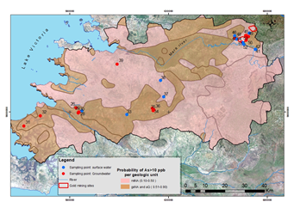Figure 2: Probability map of arsenic contaminated drinking water sources in Lake Victoria Gold Fields in Mara region.

conclusions and recommendations
Arsenic contamination in Lake Victoria Basin is a really problem in drinking water sources. The most targeted aquifers composed of migmatite-granitoid-metasediment complex and metasediments seem to have high levels of arsenic exceeding WHO guideline. The drilling practice during potable water supply should consider the type of geological units and sediments to avoid continual exposure to arsenic toxicity among Lake Victoria Basin communities. The behaviour of excess arsenic needs to be investigated with respect to seasonal variations and depth.

acknowledgements
We acknowledge the Swedish International Development Cooperation Agency (Sida) for supporting the DAFWAT program (Contribution: 51170072).

references
Ahoulé, D.G., Lalanne, F., Mendret, J., Brosillon, S. & Maïga, A.H. 2015. Arsenic in African waters: a review. Wat. Air Soil Poll. 226(9): 302.
Lucca, E. 2017. Geochemical Investigation of Arsenic in Drinking Water Sources in Proximity of Gold Mining Areas in the Lake Victoria Basin, in Tanzania. KTH Royal Institute of Technology, MSc Thesis.
Kassenga, G.R. & Mato, R.R. 2008. Arsenic contamination levels in drinking water sources in mining areas in Lake Victoria Basin, Tanzania, and its removal using stabilized ferralsols. International Journal of Biological and Chemical Sciences 2(4): 389-400.
Mnali, S. 2001. Assessment of heavy metal pollution in the Lupa gold field, SW Tanzania. Tanzania Journal of Science 27(2): 15-22.

